 | Weekly Team Task Report | #1

Team: GeoLearn |  |  |  |  |  | Date: 9/26/19
Project Title: Improving elementary education with custom online enironmental science lectures

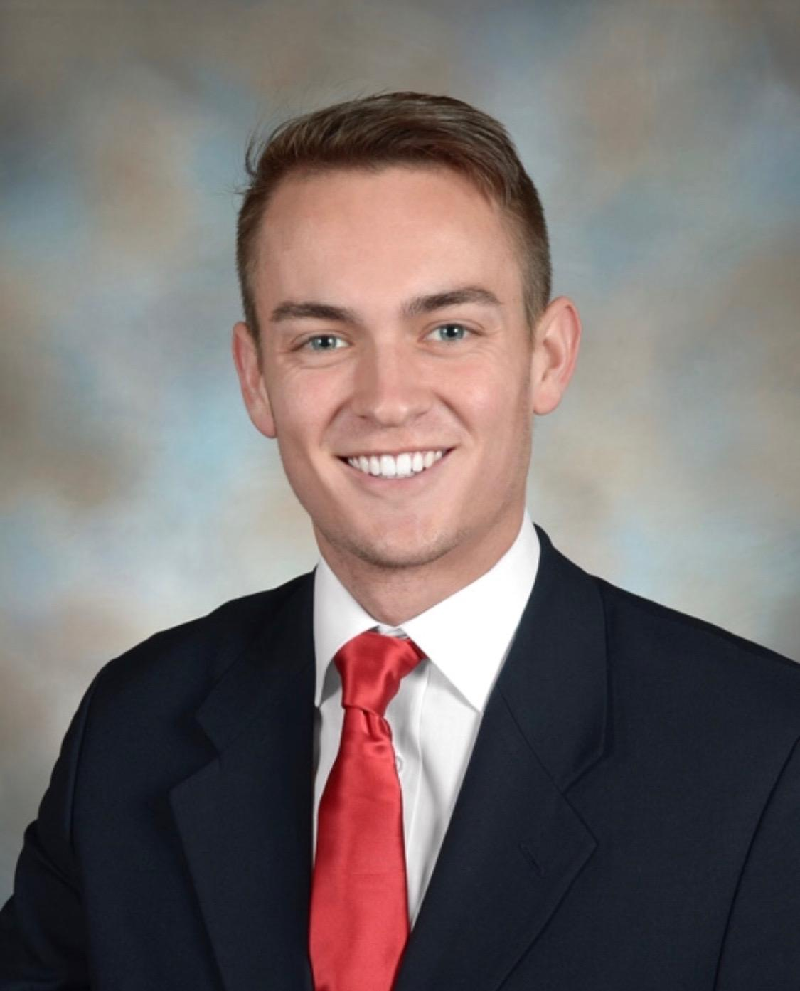 | Samuel Prassse  Present  On-time | 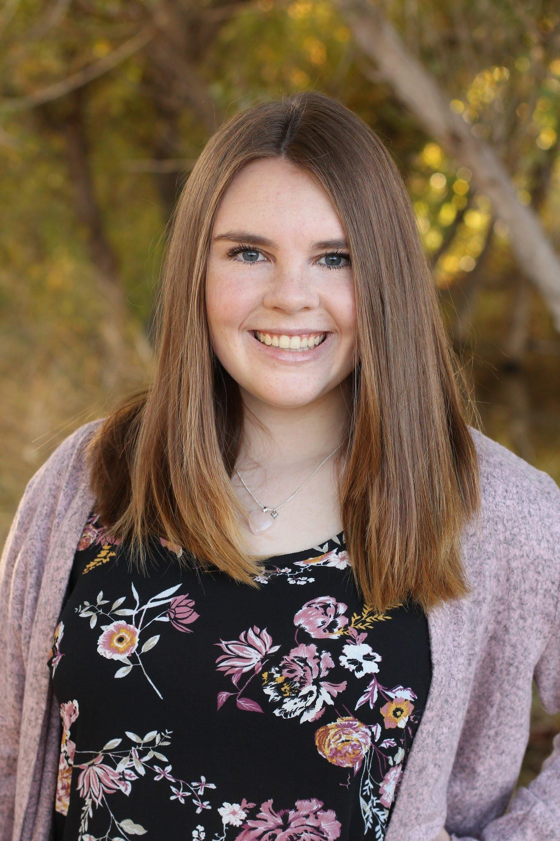 | Kaitlyn Grubb  Present  On-time | 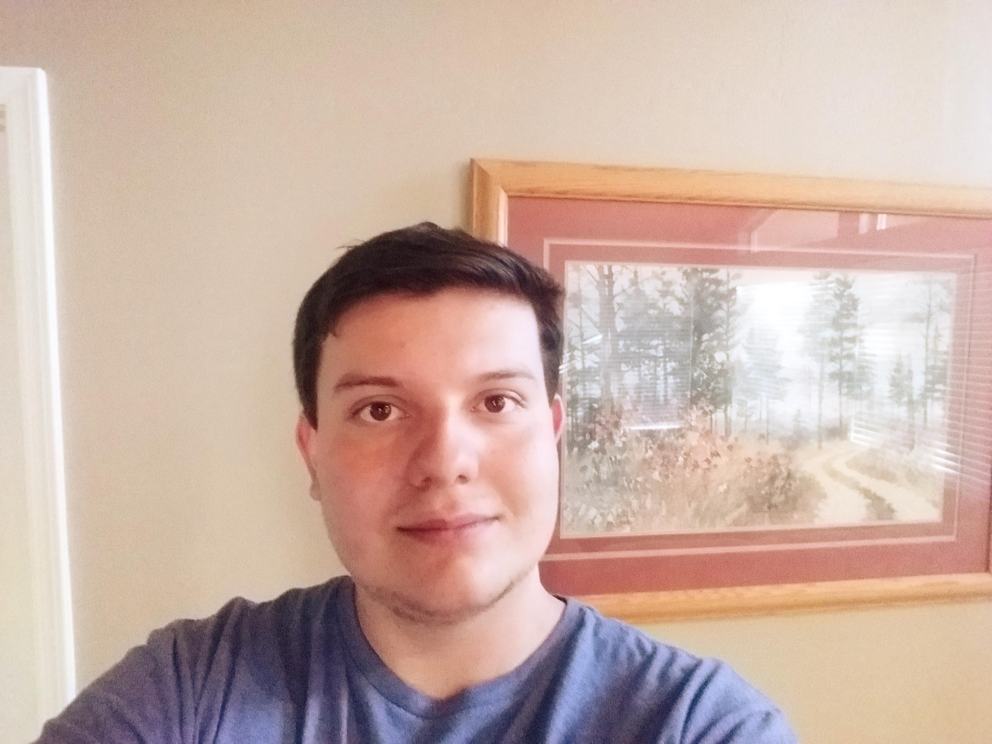 | Tyler Pehringer  Present  On-time |  | 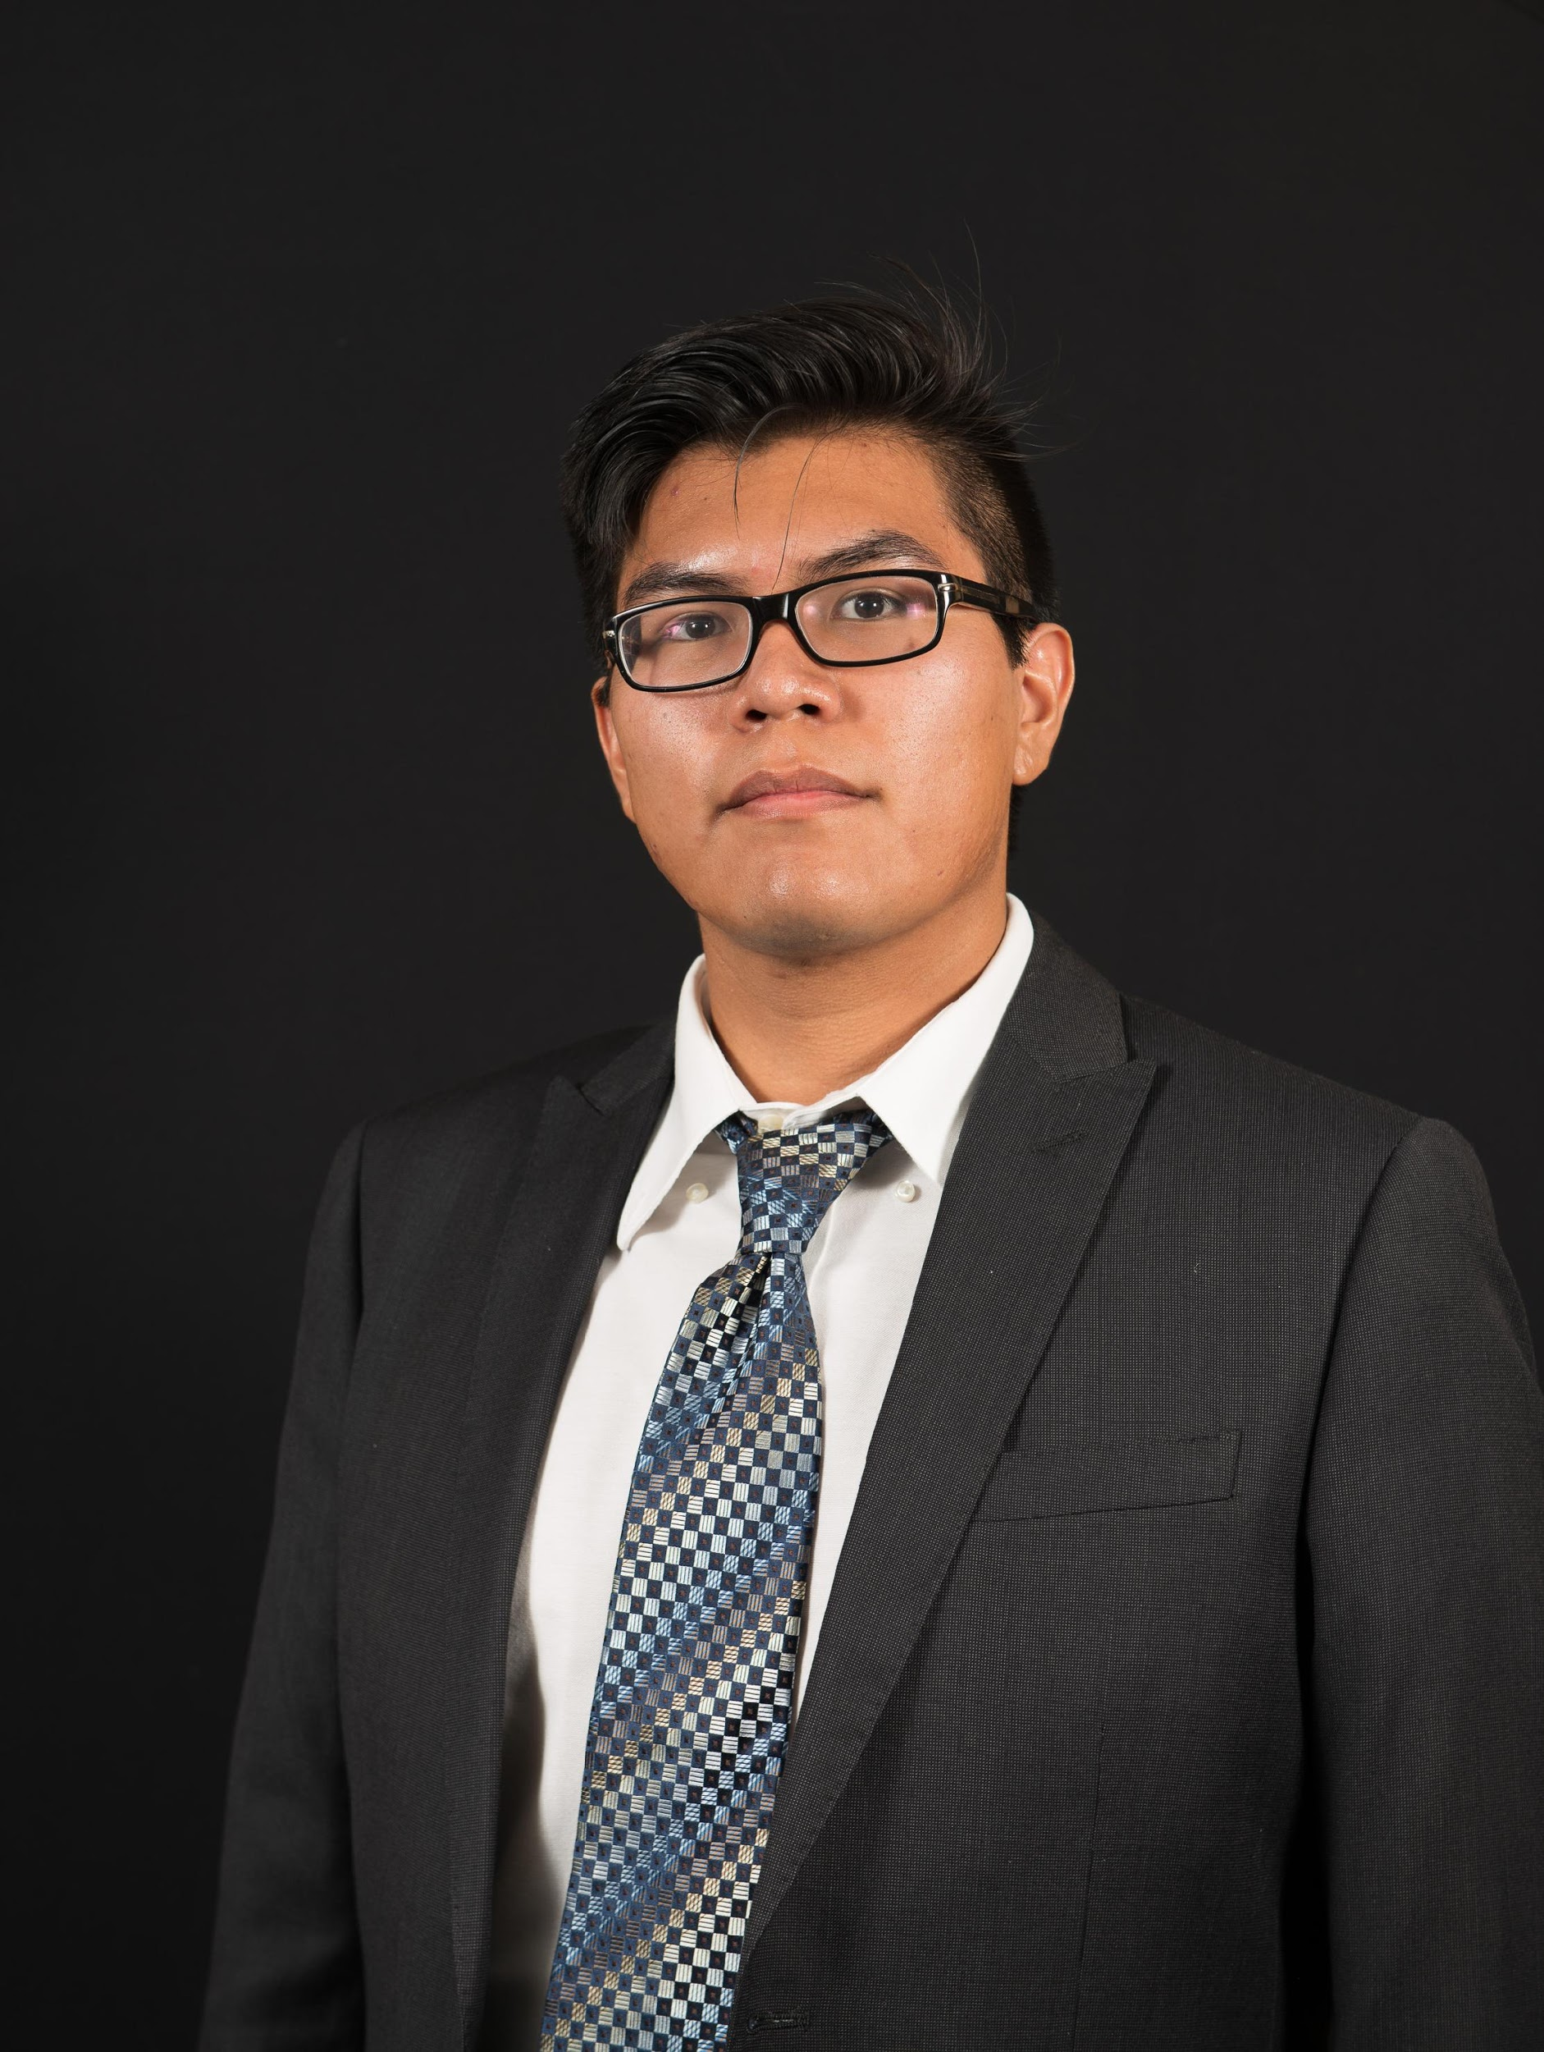 | Joshus Tenakhongva  Present  On-time

Recent Meetings:
- General Team Meeting (9/24)
- Mentor Meeting (9/26)
- Sponsor Meeting (TBD)

TASKS COMPLETED since last meeting:
Task Title: Create a Drive | Task Initiation:  9/23 | Orig. Due Date: 9/23 | Status: Completed
Who (%): Samuel (85%), Kaitlyn (5%), Joshsus (5%), Tyler (5%)
Description: Created a Google Drive to store all pertinent files and documents for the team.
Expected Outcome: To have a hub for our team data.

Task Title: Create a Github | Task Initiation:  9/22 | Orig. Due Date: 9/22 | Status: Completed
Who (%): Tyler (85%), Kaitlyn (5%), Joshsus (5%), Samuel (5%)
Description: Created a Github to store our code and documentation of the project.
Expected Outcome: To have a way to store updated and complete code.

Task Title: Create a Logo | Task Initiation:  9/23 | Orig. Due Date: 9/23 | Status: Completed
Who (%): Kaitlyn (85%), Samuel (5%), Joshsus (5%), Tyler (5%)
Description: Created a team logo; one in original quality and one in 80x80px for thte Teams Page.
Expected Outcome: Have a clean and readable logo that people will recognize.

Task Title: Emailed Mentor, Sponsor, and Course Organizer | Task Initiation:  9/22 | Orig. Due Date: 9/23 | Status: Completed
Who (%): Samuel (70%), Kaitlyn (10%), Joshsus (10%), Tyler (10%)
Description: Emailed our team mentor and set up a meeting for Thursday the 26th of September at Cline Library in room 183 at 2pm. Emailed team sponsor to set up a meeting to discuss project development. Meeting time and location is still TBD as of the 24th of September. Emailed the course organizer Dr. D with our group name, team leader, team logo, and Face Sheet and this was approved and accepted by him.
Expected Outcome: To lay the basis for our capstone project and begin to work with each other on tasks. All tasks were completed on time and provided the team a good look into what the year will look like.

Task Title: Team Standard | Task Initiation:  9/24 | Orig. Due Date: 9/24 | Status: In Progress
Who (%): Samuel (25%), Kaitlyn (25%), Joshsus (25%), Tyler (25%)
Description: The team met on Tuesday the 24th of September to complete the Team Standards document to turn in to the team mentor on Thursday the 26th of September. This document involved creating a cover page which includes the date, team name, project sponsor, faculty mentor, and list of team members. Our cover page also includes the ‘GeoLearn’ team logo. The most important part of the document is the list of team members and their roles which we have clearly defined in our document.
Expected Outcome: To present this document to our team mentor to inform them and take criticism of the standards that we have layed out to follow for the semester.

Task Title: Team Inventory | Task Initiation:  9/24 | Orig. Due Date: 9/24 | Status: In Progress
Who (%): Samuel (25%), Kaitlyn (25%), Joshsus (25%), Tyler (25%)
Description: Each team member completed a page to contribute to the team inventory. This page consisted of Bibliographical information, education, work experience, skills, and any other interests. This will provide the team with a good insight into what each members strengths and weaknesses are.
Expected Outcome: To provide to our team sponsor to inform him of the teams skill, strengths and weaknesses. This will be instrumental in assigning individual task assignments, project selection, and overall project management.

This week’s Tasks: Work plan for coming week
Task Title: Conflict Management Lecture | Task Initiation: 9/27 | Orig. Due Date: 9/27 | Status: Upcoming
Who (%): Team (100%)
Description: The team will attend the lecture on Conflict Management on Friday the 27th of September. Notes will be taken and information applied to the group’s dynamic.
Expected Outcome: Gain knowledge of Conflict Management.

Upcoming Tasks: Planning
Task Title: Project Mini Intro | Who (%): Samuel (25%), Kaitlyn (25%), Joshus (25%), Tyler (25%) | Rough Due Date: 10/3/19
Description: This task is an outline of everything we need to know about out client and our project.

Task Title: Finish Website Design | Who (%): Samuel (25%), Kaitlyn (25%), Joshus (25%), Tyler (25%) | Rough Due Date: 10/5/19
Description: We will be finishing the basic design of our team website next week.

Other Problems / Other Issues:
- N/A

